From www.handoutsonline.com © Handouts Online


STUDENT A
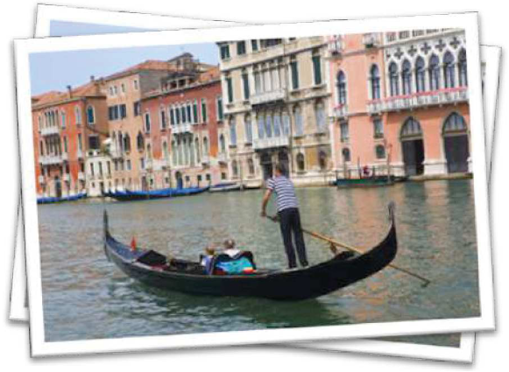

Mr. Sanders went to……………….. last month. He stayed there for two weeks. First, he flew to……………….... He stayed in a fantastic hotel. He really liked the city because ……………... On the first day, he visited the Coliseum. In the afternoon, he went to …………….... He thought St. Peter’s was wonderful.

After Rome, Mr. Sanders went to Venice. This city was very dif-ferent from Rome, he thought. He rode a gondola ……………….

times. He took pictures of the canals. He stayed in a …………………….. near the Grand Canal. His favorite food was pasta. He drank quite a lot of ……………………….

Finally, Mr. Sanders went to Milan. Everyday he …………………………. . He bought some designer goods. On the last day, he went to …………………………….. . He sent some postcards to his friends.

At Milan Airport, Mr. Sanders bought………………………. He got some more souvenirs for his family.
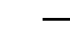

!

From www.handoutsonline.com © Handouts Online


Write questions.
1. | When | ? |  | He went to Italy last month.
2. | Where | ? |  | He flew to Rome first.
3. |  | ? |  | He liked Rome because it's very historical.
4. |  | ? |  | He went to Venice after Rome.
5. |  | ? |  | He stayed in a cheap hotel.
6. |  | ? |  | He rode a gondola three times.
7. |  | ? |  | He took pictures of the canals.
8. |  | ? |  | His favorite food was pasta.
9. |  | ? |  | He bought some designer goods in Milan.
10. |  | ? |  | He sent postcards to his friends.
11. |  | ? |  | He bought a lot of duty free goods at
 |  |  |  | Milan airport.
12. |  | ? |  | He got some souvenirs for his family.

